**Christiane Marlon F. Barcebal**

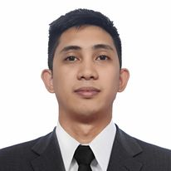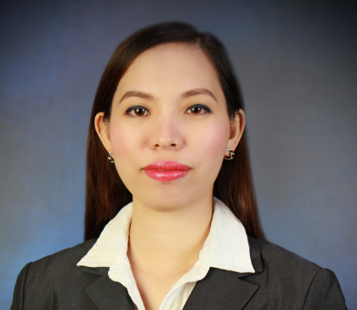

#1256 Soriano St. Sta.Rita Olongapo City Philippines 2209

Mobile No.: +639498555775

Email Add: barcebalfchristiane@gmail.com

**POSITION DESIRED: FACTORY WORKER/FOOD PROCESSING/BAKER**

**OBJECTIVE**

Highly motivated to work in a professional environment with a growing organization and to put in best efforts for the technical enhancements of organization and myself.

**PERSONAL DATA**

Date of Birth : June 26, 1999

Civil Status : Single

Height : 167.74 cm

Weight : 65 kg

Nationality : Filipino

**WORK EXPERIENCE**

1. Position : **Bartender / Waiter/ Baker Helper**

Duration : November 1, 2021 up to present

Company : Central Park Reef Resort

Location : 888 National Highway Barrio Barretto, Olongapo, Subic,

2200 Zambales, Philippines

Job Description

* Greet customers and present menus.
* Interact with customers, take orders and serve snacks and drinks.
* Assess customers' needs and preferences and make recommendations.
* Prepare alcohol or non-alcohol beverages for bar and restaurant
* Mix ingredients to prepare cocktails.
* Bussed and reset tables quickly with correct place settings.
* Set-up buffet according to procedures with food and utensils.
* Assist bakers and pastry chefs
* Do packaging baked goods
* Maintaining a clean and tidy baked goods counter

1. Position : **Production Operator**

Duration : February 2021 – October 2021

Company : Sanyo Denki

Location : Subic Techno Park, Boton Area, SBFZ, Olongapo City

Techno Park, Subic Bay Freeport Zone, Bataan, Philippines

Job Description

* Work in assembly lines to perform tasks like assembling products
* Inspect parts using measuring tools
* Set up machines to start production cycle
* Adjust machine controls to ensure quality output.
* Maintaining workstations clean
* Tagging products,
* Preparing goods for shipment

1. Position : **Service Associates**

Duration : Nov. 18, 2019 – March 17, 2020

Company : Acea Subic Bay Resort

Location : San Bernardino Road, Subic Bay Freeport Zone, 2200

Zambales, Philippines

Job Description

* Sorting items and checking for stains.
* Loading items into a machine and finishing by drying, folding and packing. Greet customers and present menus.
* Interact with customers, take orders and serve snacks and drinks.
* Assess customers' needs and preferences and make recommendations.
* Prepare alcohol or non-alcohol beverages for bar and restaurant
* Mix ingredients to prepare cocktails.
* Bussed and reset tables quickly with correct place settings.
* Set-up buffet according to procedures with food and utensils.

1. Position : **Production Assistant**

Duration : February 6, 2018 – September 10, 2018

Company : Datian Subic Shoes Inc.

Location : R8C4+MMR, Subic Bay Freeport Zone, Zambales,

Philippines

Job Description

* Preparing production line materials
* Ensuring production events are executed smoothly and efficiently
* Monitoring the production line process.
* Handles outgoing products to warehouse for shipping

**EDUCATION**

**College** **Hotel and Restaurant Services**

Capstone Institute of Business and Arts

795 Rizal Avenue Extension, Olongapo, 2200 Zambales, Philippines

Undergraduate

**Secondary** Sta. Rita National High School

Subic, Zambales

June 2011 – April 2015

**SKILL**

* **Physical stamina**
* **Multitasking skills**
* **Attention to detail**
* Reliable
* Teamwork.
* Respect for others.
* Cleanliness.
* Flexibility.
* Have strong communication skills

**CHARACTER REFERENCE**

**Mr. Mark Anthony Ranido** Restaurant Team Leader

Central Park Reef Resort

+639271875060

**Mr. Jason Jake Lantano** Company HR Staff

Central Park Reef Resort.

+639673902732

*I hereby certified that the above information is true and correct to the best of my knowledge and belief.*

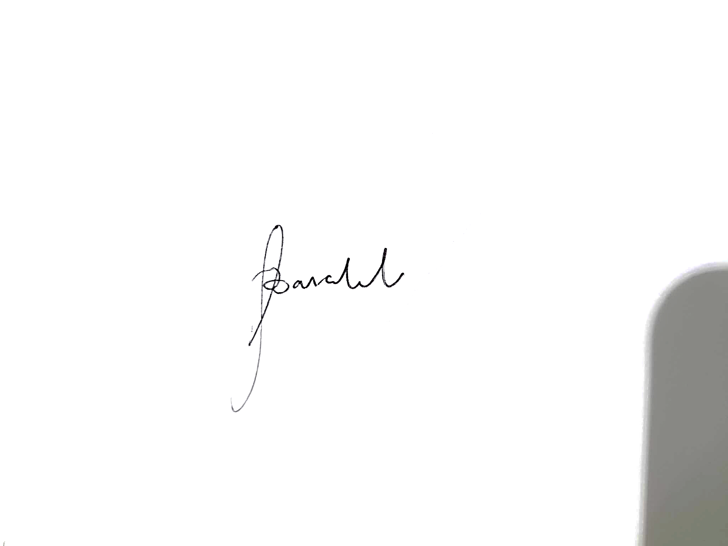

**Christian Marlon F. Barcebal**

***Applicant***